Senior Design Project 9
Generic Armored Vehicle Power Control Handle
Final Design Deliverable

Client:

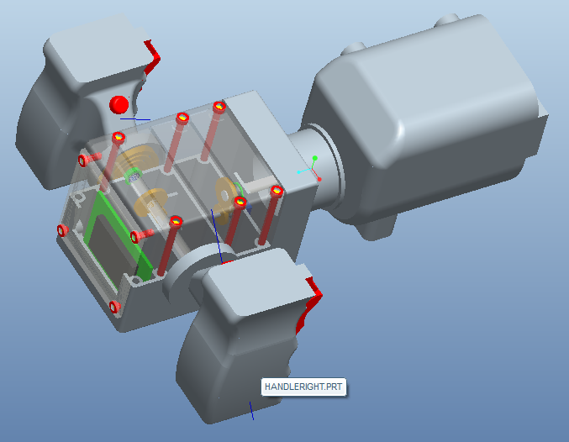

Group 9:
Michael D. Brown
William Thornton
Deanna McKenzie

December 6, 2010
Contents
List of Figures 3
1 Introduction 4
2 Design Philosophy 4
3 Design Requirements 5
3.1 Customer Needs 5
4 Design Concepts 5
4.1 Center Body Design 5
4.2 Steering Sensing Methods 6
4.2.1 Concept 1: Resistant material conduction 6
4.2.2 Concept 2: Small Potentiometer 7
4.2.3 Concept 3: Car Steering Wheel sensor 8
4.2.4 Summary 9
4.3 Haptics 10
4.3.1 Vibration 10
4.3.2Force Feel 10
4.3.3 Friction 11
4.3.4 Summary 12
4.4 Design Concepts for Adaptable Handles 13
4.4.1 Removable Grip Covers 13
4.4.2 Replaceable Handles 14
4.4.3 Concept Comparison 15
4.4.4 Summary 15

List of Figures

Figure 4: Drawing of resistive material conduction design 6
Figure 5: Snap in Roller Figure 6: Small Potentiometer 6
Figure 7: Potentiometer, gearing and handle shaft Figure 8: Potentiometer gearing and center shaft 7
Figure 9: Steering Wheel Sensor 8
Figure 10: Vibration motor used for cell phones Figure 11: Vibrating motor from Tickle me Elmo 10
Figure 12: Torsion Spring 11
Figure 13: Fexinol Wire 11
Figure 14: Torsion Spring on Handle 12
Figure 15: Permanently mounted handle with removable cover 13
Figure 16: Removable Handles 14
Figure 17: M1-Abrams Handle Figure 18: M2 Bradley Handle 15

1 Introduction
Lockheed Martin currently makes an Advanced Gunnery Training System (AGTS) for the purpose of training troops to operate armored vehicles for the military. As of right now, this training system consists of many different types of heavy handles that currently lack the “feel” of the armored vehicles they are supposed to be mimicking. Our main goal is to design a generic gunnery trainer handle that is both lightweight and compatible with many different simulations. We hope to have a lightweight, fully functional handle with the proper type of feel and an assortment of different “settings” to accurately mimic the armored vehicles’ motions.

2 Design Philosophy
Our design aims to both meet and exceed the expectations of the client. As listed above, many requirements were specified by the client, but there was room to design independently, leaving the ability to think critically about what needed to be accomplished. As will be discussed in the Design Concepts section, the problems faced were approached in a professional and all inclusive manner, allowing for a well-rounded design methodology that will both provide a route to the client’s desired outcome and allows for innovative idea generation.

3 Design Requirements

3.1 Customer Needs
Lockheed Martin has expressed a need for a multi-compatible simulation gunnery control handle for use in training simulators. For ease of transport, assembly, and general use, the client has asked for this “multi-compatible” handle to support the inclusion of both the M1 Abrams and the M2 Bradley control handle configurations. The handle should also be able to not only replicate the handle shape, but its general “force feel” as well. After a handle has been removed, and another attached, there should be a method to change this “force feel” to suit the desired characteristics of the new handle configuration. These handles should attach and detach from a common “center body” designed as per client specs given in the Statement of Work. Lastly, the “force feel” characteristics of each handle calls for a full angle rotation of 150˚ for both that handle shaft and the center shaft.
The client has also specified requirements for engineering materials on some components. For instance, the center body should be constructed of an engineering plastic to withstand force testing as per specs provided by client. Hardware is to be stainless steel as is the gearing for use with the potentiometers. Both the center shaft and the handle shaft are to be made of stainless steel. All bearings are to be stainless steel ball bearings. All springs are to be counter-clock type opposing springs and the output of the device is to be USB so as to allow for connection with any type of computer.

4 Design Concepts
There were a few preliminary designs for the various parts of the control handle. Due to the intrinsic complexity of the project, there aren’t a series of solidified full designs for the entire project, but instead a myriad of smaller conceptual designs that could be implemented into the final design. For this reason, the design concepts with be split up into four separate categories, and then specific component designs will be divvied up into those categories depending on their desired applications. The categories to be explored are Center Body Design, Steering Sensing Methods, Haptic Response Methods, and Handle Adaptation Methods.

4.1 Center Body Design
One of the main requirements expressed by the client for the Gunnery Control Handle is that the center body of the assembly be made out of an engineering plastic that will stand up to testing as per specs listed in the Statement of Work provided. It was to remain within some previously specified dimensions, and it should be able to contain all of the components necessary for a working control handle. There were three fundamentally different types of center body assemblies considered, mainly distinguishable by the ways in which one can access the inside components. The first method is a horizontal separation method shown in Figure 1 below, wherein the front and back parts of the center body can separate. The second type is a vertical separation shown in Figure 2 below, wherein the top and bottom parts of the center body can separate. Lastly, the third option, shown in Figure 3 below, is a hybrid between the two types of separation with the addition of a detachable back plate.

4.1.1 Horizontal Separation Center Body
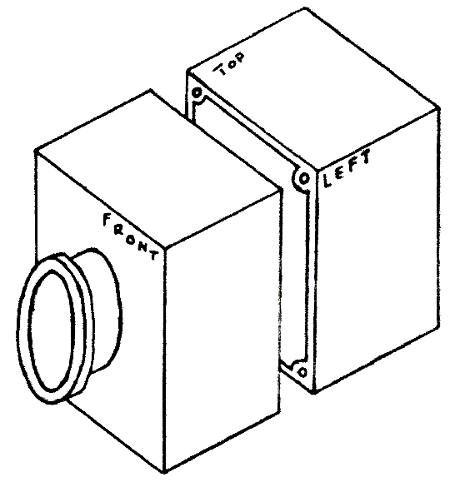
Figure 1: Horizontal Separation Method
The horizontal separation method, as shown in Figure 1 above, allows for the components contained within the center body to be accessed by detaching the back of the center body. This is the basic design of the current trainer handles used for the gunnery simulations. This back portion would be attached using hex screws and possibly, but not necessarily, bolts.
This center body construction would allow for easy access to the components inside the center body, however, since the dimensions provided by the client show the length of the center body longer than the height, this design would force our design to either design components into the part of the body that is disconnected or to make components harder to get to because of a farther distance between them and the opening. These two options depend on where the separation is made and how components are positioned within the center body.

4.1.2 Vertical Separation Center Body
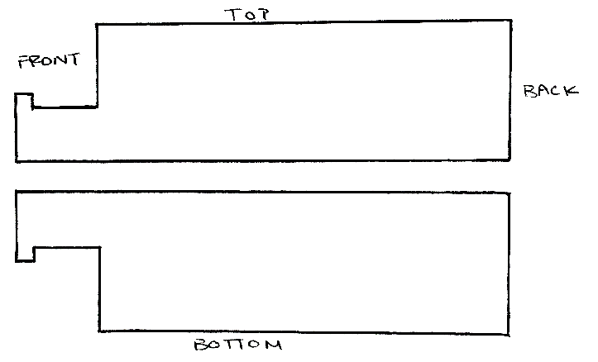
Figure 2: Vertical Separation Method
The vertical separation method, as shown in Figure 2 above, allows for the components contained within the center body to be accessed by detaching the top of the center body. This effect would be achieved by attaching the bottom portion permanently to the center shaft that comes out of the front of the center body. This would allow for the top to be detached to expose the interior. As with the previous design concept, the top portion would be connected using hex screws or bolts.
The vertical separation design will allow for a full view of all components contained within the center body. It does present problems as to how the top section will be detached with the bottom section still secured. This design will also require a fair amount of problems when manipulating the torsions springs what will reside within the front of the center body. These springs will be contained in the circular part of the center body, seen better in Figure 1.

4.1.3 Partial Top and Back (Hybrid) Separation Center Body
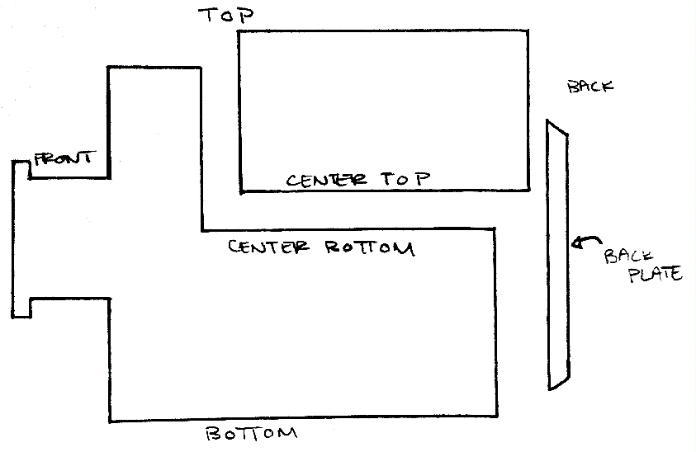
Figure 3: Back and Partial Top (Hybrid) Separation Method
The hybrid separation method is a combination of three parts: the center bottom, the center top and the back plate. The center top will attach to the center bottom and allow for full access to components inside along the length of the center body. The removal of the back plate will also allow access to the back of the center body without removing the center top. As with the other concepts, these components will be secured using hex screws or bolts.
This method employs ideas from both Concepts 1 & 2 and eliminates problems encountered in both of those designs. The design is equipped to allow for full access to all components along the length of the center body while still leaving the front of the assembly closed, eliminating the need to worry about the torsion springs that reside there. Since the micro controller in the final design will be placed near the back of the center body, there is a back plate that can be removed to present quick access to this component and some others if small tweaking is needed. One downside to this design is the need to take off both the back plate and the top when accessing components near the front of the center body.

4.1.4 Summary
Both Concepts 1 and 2 have their problems. Concept 1 will not allow proper access to all the components or it will make the component placement a problem when removing the back of the center body. Concept 2 will allow for full access to the components lengthwise, but causes problems due to the springs at the front of the design that would need to be handled every time the top was taken off. Concept 3 is a design that is made to take care of both of these problems while still maintaining the pros of each. The only downside to Concept 3 is the added time in taking off the back plate, but time will also be saved when only the micro controller needs to be accessed because of its position within the center body. For these reasons, Concept 3 is the final concept for the center body of the Gunnery Control Handle.

4.2 Steering Sensing Methods
The first concept utilizes the principle of reading a change in voltage by using a large piece of material with a measurable resistance. As can be seen in Figure 4 below, this material wraps around the shaft a full 150 degrees; the full angle rotation required by the client. There is a wire connected to one side of the material with the other end connected to a voltmeter. Another wire connects the voltmeter to a swinging arm which is rigidly attached to the turning shaft. The voltmeter will then be able to measure the voltage across the resistive material. As the control handle turns, so does the shaft. This moves the swinging arm across the resistive material, either increasing or decreasing the resistance. This is in essence a large version of a variable resistor, or a potentiometer. As a side note, some materials that can be used for the resistive material are a doped carbon material, a ceramic-metal composite, or a conductive plastic material.

4.2.1 Concept 1: Resistant material conduction
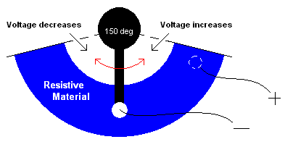
Figure 4: Drawing of resistive material conduction design
This design has many plus sides, one of which is its simplicity. The only moving part is its swinging arm, which is rigidly connected to the shaft. This means that there is no conversion between the angle that the shaft moves and the angle that the swinging arm moves. Another good thing about this design is that it uses very few parts. It uses a swinging arm, two wires, and a curved resistive material. Although this design is promising, it still has some flaws. Firstly, with the exception of the wires, the other parts will have to be fabricated. Even though this is not an insurmountable hurdle, it adds to both the cost and time to this design. Unless common prefabricated materials can be used, these problems will be a base concern going forward from this design. Secondly, this design may be on the large side. Even though there is room in the plastic shell body that contains the shafts, it would be easier to use a smaller component.

4.2.2 Concept 2: Small Potentiometer
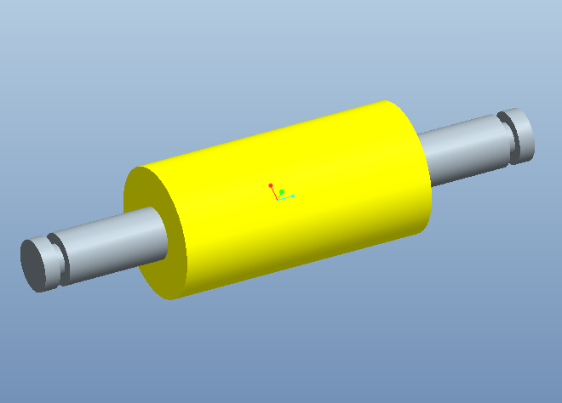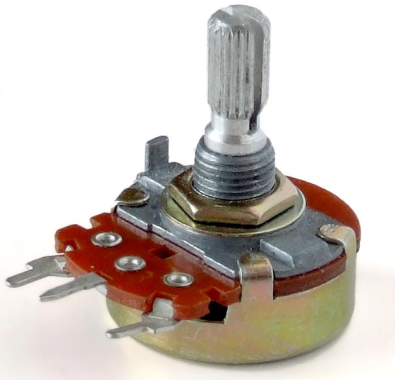
Figure 5: Snap in Roller Figure 6: Small Potentiometer
The second concept for the sensing capabilities of the gunner’s handle utilizes the components found in Figures 5 and 6. Figure 5 shows a small roller like one might see inside a mouse that uses a trackball instead of a laser. These mice have two small rollers that can register the direction of the mouse ball’s movement, and its rotation velocity as well. Figure 6 shows a common potentiometer that can be purchased at any electrical component store. This potentiometer, like the larger one in Concept 1, measures a change in voltage when the rotation arm is twisted. The simulator can then read this voltage change as a change in the steering shaft’s angle. The idea is that the rollers would snap into part of the skeleton design next to whichever steering shaft it is measuring. The axis of the roller will be connected to the rotation arm of the potentiometer, meaning that when the roller is turned by friction with the shaft, the potentiometer’s rotation arm is also turned, changing the voltage reading. This design may need to use gears, if the contact between the shaft and roller doesn’t provide enough friction.
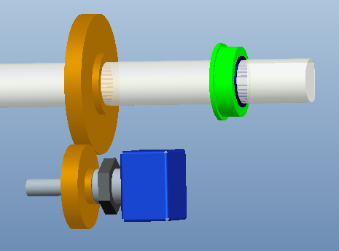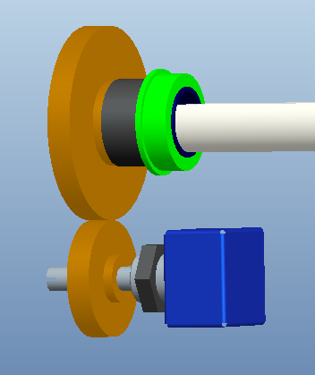
Figure 7: Potentiometer, gearing and handle shaft Figure 8: Potentiometer gearing and center shaft
Gearing, although relatively complicated in design, would not be very hard to implement. There is room in the plastic casing to accommodate gears as long as they aren’t too large. A gear assembly as you might see it in the Gunnery Control Handle is represented above by Figures 7 & 8 above for the shaft controlling connected to the handles and the shaft connected to the center respectively. This configuration is designed for a potentiometer that has at least 250˚ of rotation possible. These gears aren’t shown with teeth.
The best part about this design is the fact that all of its parts are cheap (with the exception of the gears) and can be purchased quickly. If the roller can be integrated into the plastic outer shell of the handle, it is also extremely easy to install and replace. If gears are necessary, they will only need to be secured to the potentiometer shaft and the respective shafts they are reading. One downside to this design is the implementation of a more complicated potentiometer. This potentiometer utilizes more parts than the previously proposed component, which means that there are more parts that can break. However, this problem may be outweighed by the ease and affordability of replacement. Also, this design is moderately more complicated because of the difference in the angular displacement of the roller and the shaft itself. Lastly, it may be necessary to recalibrate this design often, because the design assumes no slip between the roller and the shaft. This problem is, of course, nullified if gears need to be implemented.

4.2.3 Concept 3: Car Steering Wheel sensor
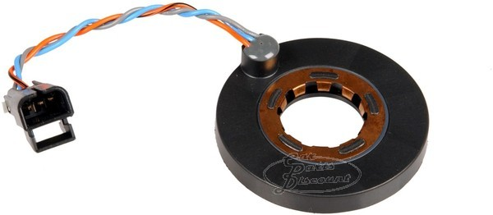
Figure 9: Steering Wheel Sensor
The last of our ideas for sensing methods involve the implementation of a common steering wheel sensor. This would be an extremely easy solution to a complicated problem because it is a one component installation process. The main idea is to simply slip the steering wheel sensor around the shaft whose rotation is being read before it is installed. Like the other concepts, this idea is basically a potentiometer which gives a voltage difference in response to rotation.
This design would be an ideal solution to the problem of sensing shaft rotation because of the devices durability and easy installation, but the installation could become more complicated depending on the steering wheel sensors turning resolution. Most steering wheels are designed to have a full angle turn around 1400 degrees, meaning that our steering wheel (150 degrees full angle) isn’t using the entire capability of the steering sensor. Since the sensor was made to read large full angle turns, the resolution for 150 degrees of turn might be quite low. The installation complication arises when trying to fix this problem. Something like a gearing system would have to be implemented. The sub-components of the steering sensor will complicate any repair that is necessary, but since these sensors cost on average around $30 they can be replaced cheaply. The installation, although difficult, would not need to be done very often since these components are made to be rugged.

4.2.4 Summary
In comparison, all of these components have their pros and cons. Concept 1 is simple, and yet it uses materials that will probably not be readily available. It is a very straightforward design and doesn’t need any sort of gearing system to account for low angle resolution. Its installation, although easy to implement, makes for difficult replacement of parts. Concept 2 involves two basic, simple components that are both easily bought and installed. These components are readily available in most places. This concept is designed to use friction with the shaft to turn the potentiometer, but it may be necessary to use gears. Even though it’s simple, the small potentiometers used may not be as durable as needed. This however may be offset by the fact that they’re inexpensive. Concept 3 is both durable and has only one part that needs to be handled. This one component has many subcomponents which heighten the likelihood of malfunction, but this may not be a problem because steering wheel sensors are made to be rugged. This design would also be more difficult to install than the other two, but this may be outweighed by its durability, meaning it won’t have to be replaced often.
Table 1: Decision Matrix
 | Importance | Concept 1 |  | Concept 2 |  | Concept 3
 | Importance | Rating | Weighted  Score | Rating | Weighted  Score | Rating | Weighted  Score
Durability | 30% | 7 | 2.1 | 6 | 1.8 | 9 | 2.7
Ease of Installation | 30% | 6 | 1.8 | 9.5 | 2.85 | 5 | 1.5
Affordability | 25% | 6 | 1.5 | 8.5 | 2.13 | 8 | 2.0
Simplicity | 15% | 7 | 1.05 | 7 | 1.05 | 7.5 | 1.13
Weighted Scores | NA | 5.48 |  | 6.88 |  | 6.45
The decision matrix was built by using ratings of importance for each engineering aspect. Durability and ease of installation ranked highest; both holding a weight of 30% each of the total score. Affordability, although important, is not quite as important as either of the first two aspects, which is why its score is only 25%. Simplicity is always important in a design, but since these concepts were scored for their relative simplicity, this weight is of lower importance. This is mostly because even though some of the designs are clearly simpler than others, they are all fairly simple to begin with. After relative scoring was done on a scale of 1 to 10 (1 = very poor; 5 = fair; 10 = excellent), those scores where then multiplied by their importance values and added together for each concept. The Weighted Scores row is the result of those scores. In the end, Concept 2, the concept which utilizes a small roller and potentiometer won for its affordability and ease of installation. Its simplicity was between the other two concepts, and its durability was below that of the other two.

4.3 Haptics
Haptic response is the general feel, vibration, or motion that the user of feels from the handles. The concept of haptics with the gunner control handle includes an idea of vibration, force feel, and friction.

4.3.1 Vibration
The vibration idea would be similar to a video game controller such that the when the gamer hits an object in the game the remote vibrates, or a cell phone when the user touches their screen the phone vibrates to simulate a button being pressed. This will apply to the gunner’s handle also which means that when the user hits a bump or a target then the handle will vibrate. The vibration concept is the simplest and cheapest of the three with vibration motors and weights.
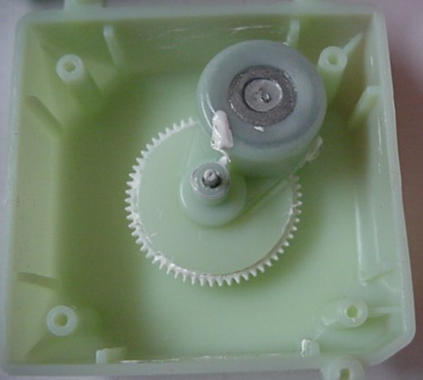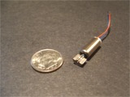
Figure 10: Vibration motor used for cell phones Figure 11: Vibrating motor from Tickle me Elmo

4.3.2 Force Feel
Force feel means that the force felt by the user on the handle is realistic. The handle should give an opposing force when the user encounters an obstacle in simulation. This will improve the simulation and provide an accurate learning experience.
One concept to implement the force feel we have investigated using motors to push back on the user. The motors will be controlled by a program that can respond to objects in simulation. These motors would be directly attached to the roll axis and indirectly attached to the pitch axis. The pitch axis motor will use a series of cables and pulleys in order to actuate and apply the force needed.
A draw back to the motors for force feel is the amount of space inside the handle versus the size and power of the motor. Usually the size of the motor is proportional to the amount of power it puts out. The motor controller or encoder will also have to be taken into consideration.
Another very simple force feel haptic response could be accomplished with the use of torsion springs. The springs, pictured below, could be matched too fit the response of the handle being used. The springs would be used to oppose the turning of the handles and return them back to the straight. The springs would be adjusted to match the vehicle by using a completely different spring for every handle configuration. The main issue with this concept is developing a method of changing the springs when to match each vehicle.
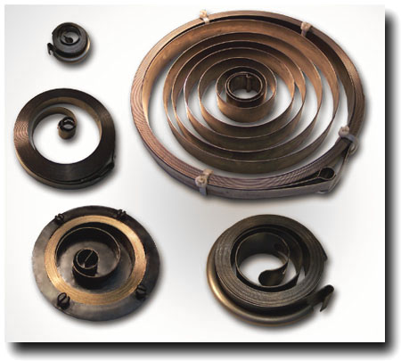
Figure 12: Torsion Spring

4.3.3 Friction
The concept of adding friction to the handle’s haptics consists of making the handle feel heavier than it is since it will mostly be plastic. The friction control will add a level of resistance to the simulation experience which in turn adds realism and a sense of driving a heavy object.
An idea of the friction control is trying to “gum up” the controls. In order to implement this we have explored springs to provide this resistance. The springs would be mounted in some way to each axis. Another benefit of the springs is the handle will return to its original position which is be good for encoders and reading positions on potentiometer.
Another concept is using Flexinol wire, a metal wire that contracts when heated and expands when cooled off. This wire would be attached to each shaft and electrical wires on each end of the Flexinol wire to provide heat, the Flexinol will contract and give a resistance to the user. The biggest advantage of this wire is the cost; the flexinol is about $3.00 per meter. This wire is also a space saver; if space is limited inside the handle then this would be the best choice.
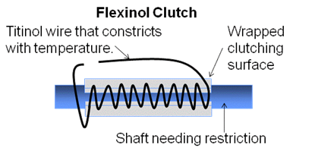
Figure 13: Fexinol Wire

4.3.4 Summary
The main issue with selecting a method of achieving haptic response was figuring out what type of haptic response was required by the customer. After talking to our sponsor it became clear that we only needed to replicate the force feel response. We then had to decide whether or not to use motors or torsion springs. The motors would have made changing the feel of each handle configuration very easy. By simply changing the speed of the motor the handles could have any response necessary. However it would also require us to put motors inside the centerbody. This created a problem because the amount of space inside the center body is very limited. The cost of the motors would also be significantly greater than the of the torsion springs. Torsion springs on the other hand are very inexpensive. The main issue with the torsion spring is that we must be able to change the springs for each handle configuration. After much consideration we decided that the torsion spring concept was far superior to the motors, because of cost, and ease of implementation. The springs will be located outside of the centerbody. One end will be attached to the shaft and the other will be attached to a peg on the outside of the centerbody. We will use two springs for each handle configuration, they will be in opposing directions in order to create uniform response in both directions.
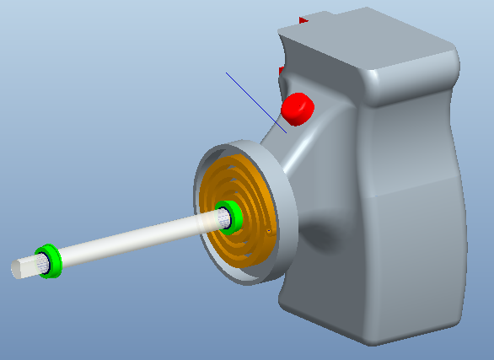
Figure 14: Torsion Spring on Handle

4.4 Design Concepts for Adaptable Handles
One of the main goals of this project is to generate a method of making the centerbody so that it can be used to replicate several different vehicles. There are several different possibilities that we researched in order to select the best choice for this project.

4.4.1 Removable Grip Covers
The first concept, pictured below, is based on having one adjustable centerpiece with a set of handles permanently attached. Since the handles are permanently attached to the center body the grips must be interchangeable. The main idea is to have an entire set of removable grips that can be easily slid over the handle. The advantages of this design are in the simplicity. This design can be changed from one form of machinery to another by simply sliding one set of grips off of the generic handle and replacing them with the appropriate grips. This design easily accomplishes our goal of making a generic trainer that is easily interchangeable for several different training simulations. Another extremely advantageous part of this design is that production of multiple handle configurations can be accomplished by simply making an inexpensive adaptable polymer grip. The replacement grips can be attached through a large variety of simple mechanisms, such as having some form of snaps that fit the grip to the generic handle. The attraction to this design comes from its overall simplicity and it’s relatively low cost of producing multiple grip configurations.
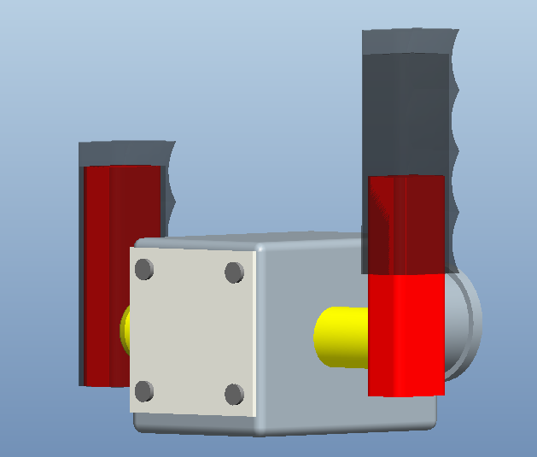
Figure 15: Permanently mounted handle with removable cover
However, like every design there are several inherent disadvantages. The greatest obstacle to overcome if we were to make this concept a reality would be to create a realistic “feel” for each of the different vehicles the trainer is to represent. To accomplish this goal would require the addition of a variable force application to all of the shafts that will resist steering forces in a similar manner as the vehicle it is to represent. While this matter mostly deals with haptics, it incorporates a significant cost to the concept of interchangeable grips that slide over a generic handle. A second issue that arises with this concept is the integration of buttons on the handle. Not all vehicles these simulations emulate have exactly the same button configuration on the handle. The buttons used for firing and other operations can have several different mounting points. With the generic permanently mounted handle it would become quite challenging to make a variable trigger placement. While this design concept is very easy to use interchangeably between vehicles and new grips would be inexpensive to produce there would be significant cost to the design process, to account for these issues.

4.4.2 Replaceable Handles
The second concept to make the center body of the trainer interchangeable between vehicles is to use replaceable handles, as seen below. By using a center body that allows the handles to be added and removed with relative ease the handles could easily be designed to represent the desired vehicle. Each removable handle would incorporate a mechanism to imitate the general frictional response to oppose steering inputs that are accompanied by the vehicle it represents. This removes the need to design a variable feel response system that can be adjusted for each type of simulation. This concept would also make replication of all buttons and triggers on the handles possible, with relative ease, making replication of the look and feel of every vehicle that is to be simulated plausible.
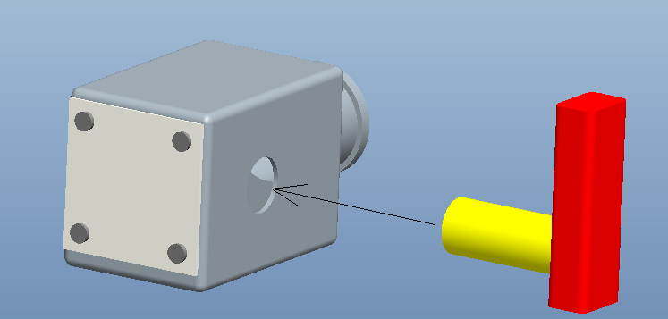
Figure 16: Removable Handles
The concept for this design sounds simple; however, there are many glaring issues that must be dealt with to make this design feasible. The two main concerns with this design are the cost and complexity. The cost of producing many handles would be expensive, because all handles would include full grips, a friction feel device, a set of handles, and a set of buttons. Compared to other concepts that require nothing more than a change of grip covers to switch between vehicle simulations, this concept is also quite complex. This design would also require the addition of an extra attachment to connect the wiring from the handle to the center body of the trainer. The addition of connections into the design makes the wiring more susceptible to exterior elements. The more connections and interfaces between wires, the greater the possibility of failure in the wiring. This design would require some mechanical means of detaching and attaching the handles, and it would also require an extra electrical interface to connect the buttons from the handle to the center body.

4.4.3 Concept Comparison
While both concepts would potentially work to accomplish our goal of creating a generic gunnery trainer center body, that is easily interchangeable between vehicle simulations, both designs are different in many ways. The main advantages of the first concept are the simplicity of changing grip configurations. The second idea however is relatively complicated to alternate between vehicles. The production cost of creating auxiliary grip configurations, for the second concept, is many times higher than the cost of producing the additional grip covers that are used in the first concept. When examining only production costs and ease of variability the first concept is far superior to the second concept in every way.
However, production cost is not the only component taken into account in the design process. The complexity of the design can also represent a large portion of the design selection. The second design incorporates a much simpler mechanism to adjust the frictional feel that opposes steering, because the frictional response can be customized to each handle configuration and integrated into each different handle; whereas the first design requires the fabrication of a device to supply a variable friction force to the handle, so that it can be adjusted for each grip configuration. The first device also requires some engineering a way to create the appropriate button configuration for each vehicle, and since the handles are permanent the buttons must either be generically placed or integrated into the removable grips. Both designs have very distinct advantages and disadvantages when evaluated against one another, we must rely on a decision matrix to find which concept best fits our criteria.

4.4.4 Summary
While both concepts could potentially work to accomplish our goal, it is necessary to choose which will be implemented in our final design. After researching both ideas, it became increasingly more obvious that the removable handles were our best option. The removable grip covers would not be capable of replicating the overall feel of the correct handle configuration. The removable grip covers would make it much harder to design the haptic response; similarly the button configuration would not be able to exactly match that of all of the handle configurations. It is because of this, and the fact that we must use the removable handles in order to implement the torsion springs to produce our haptic response, that we have selected the removable handle concept as our final design. The removable handles will connect to a permanently mounted shaft using a set screw and a key. The buttons will be replicated to match each handle configuration.
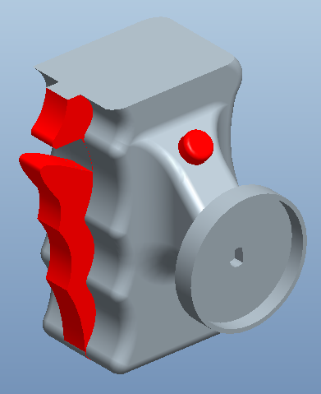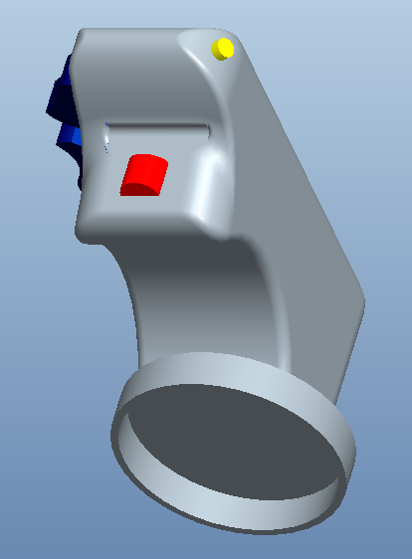
Figure 17: M1-Abrams Handle Figure 18: M2 Bradley Handle

5 Final Design

5.1 Cost Analysis
The total cost of our final design is $221.92; this includes all of the parts that we will order of the internet. However this price does not include the cost of our engineering plastic, the manufacturing cost of creating our centerbody or handles. We cannot yet calculate the manufacturing cost since we have not yet selected a material to use in our final design. Other costs that we anticipate will be the hardware used to assemble our controller, the wiring necessary to support the buttons, and the cost of any machining that must be done to our shafts and other parts in order to make them work. This cost analysis is based on the cost of parts for the creation of only one type of handle, if we generate a second handle configuration, the cost will obviously be greater. However we are still well under our budget of $2,500, and expect that we will be able to complete the project with these funds.

Table 2: Cost Analysis
Part | Quantity | Supplier | Pr ice ($) | Total Cost ($) | Item Number
Shaft | 1 | McMaster-Carr | 20.25 | 20.25 | 1263K73
Bearings | 4 | McMaster-Carr | 8.72 | 34.88 | 57155K338
Torsion Springs | 6 | McMaster-Carr | 7.88 | 47.28 | 9293K31
Microcontroller | 1 | Pololu.com | 99.95 | 29.95 | 1616
Potentiometers | 2 | Allied Electronics | 6.35 | 12.70 | 308NPC250K
Pinion Gear | 2 | SDP-SI | 13.05 | 26.10 | S11632-064S018
Gear | 2 | SDP-SI | 13.56 | 27.12 | S11632-064S030
Buttons | 6 | McMaster-Carr | 3.94 | 23.64 | 69755K31
Hardware | - | - | - | - | -
Total | $221.92

6 Final Design
The final design for the Gunnery Control Handle, as can be seen in Figures 19 & 20 below, was not merely the final product of a singular decision between design choices, but instead, a product of many different design choices first made and then assembled into the final design. Firstly, the design of the center body had to be finalized, making sure to take into account space requirements given by the client and necessary for the components to fit. Concept 3 was chosen for its ease of access to the components and its ability to keep the torsion springs in the front of the assembly secure during maintenance. Later, the methods for sensing shaft rotation on both the roll and pitch axis’ where chosen. Concept 2 was chosen for its ease of installation, its weight, and its cost. After considering many options, the choice was made as to which type of haptic feedback would be implemented. Opposing torsion springs were implemented on both the handle and center shafts, giving a smooth response to axis rotation.
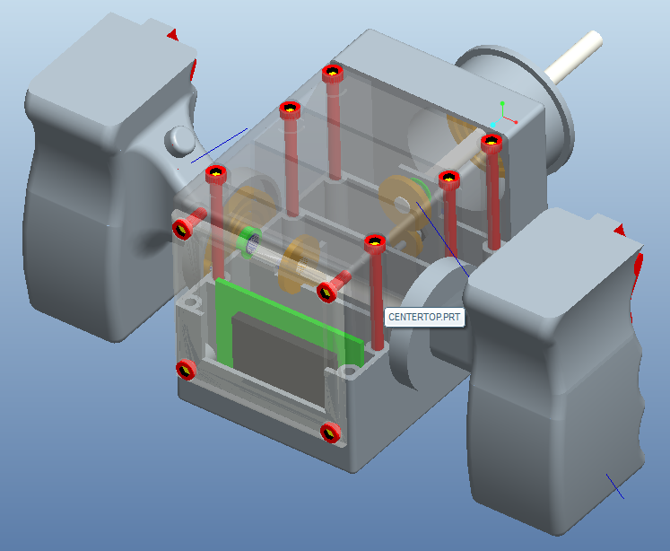
Figure 19: Control Handle Full Assembly

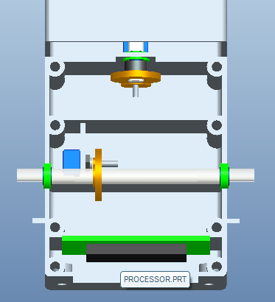
Figure 20: Interior view of Control Handle
Figure 21 below shows the final assembly attached to the mount. This mount is necessarily what ties the control handle into its final application. The handle will be implemented in the design of Group 10’s portable Gunnery Trainer. The mount connects our handle to their computer assembly, allowing combat personnel to train on the go.
Figure 21: Fully Assembled Gunnery Control Handle + Handle Mount

7 Future Plans
The next step for our group is going to be to finalize our material selection for the handle and center body. We will then order all of our parts. We will likely create a prototype out of a less expensive plastic than the ABS plastic specified. We will use this prototype to assemble our handle and make sure everything works correctly. From here we will begin optimize and test our design. We predict that this will be an iterative process requiring multiple attempts before we have our final assembly. This is the reason we will likely create our rapid prototype out of less expensive materials than those required for our final design.
Other plans for next semester include the creation of our team’s webpage; this will be accomplished sometime in January. We will also be planning a trip to General Dynamics in Tallahassee so that we can see and feel the actual handles that we are replicating. We may also be taking a trip to Orlando, to meet our company contact, Mr. Steve Preston, and share our prototype with him.

7 References

Haptics
Gabriel Robles-De-La-Torre. "International Society for Haptics: Haptic technology, an animated explanation" <http://www.isfh.org/ch.html.>
"Robles-De-La-Torre G. Virtual Reality: Touch / Haptics. In Goldstein B (Ed.), "Sage Encyclopedia of Perception". Sage Publications, Thousand Oaks CA (2009)."
Figure 6
http://upload.wikimedia.org/wikipedia/commons/b/b5/Potentiometer.jpg
Figure 9
https://www.carpartsdiscount.com/auto/archive/pictures/44276/600/1/P/2CA4435/oldsmobile_intrigue_01_steering_wheel_speed_sensor_oem_26064468.jpg
Figure 10
http://electronics.howstuffworks.com/question368.htm
Figure 11
http://pocketnow.com/thought/how-does-a-cell-phone-vibrate
Figure 12
http://valuablemechanisms.files.wordpress.com/2010/05/clock-spring.jpg
Figure 13
Courtesy of Steve Preston (behalf of Lockheed Martin)

8 Appendix
